Building Enterprise Financial Software in 2026

Change is coming, but not in the way people expect
For most of my career, large financial institutions have had two uncomfortable options when they needed serious enterprise software.
The first was to build it themselves. This was common in large banks, especially around core systems and critical post-trade infrastructure. It gave control, but it required large teams, long timelines, deep institutional memory, and a high tolerance for cost.
The second was to buy a vendor product and tailor it to the institution. That could mean hosted software, self-hosted software, or a heavily customised package. The trade-off was different, but not necessarily better. Pricing was often opaque. Timelines tended to move in proportion to complexity. Customisation created dependency. Replacement became so difficult that even problematic systems survived because the pain of moving away from them outweighed the visible benefit.
In practical terms, not much has changed in decades. We have had waves of new processes, new tools, new architectural fashions, new delivery methods, and new promises. Some helped. Few fundamentally changed the economics of building large enterprise financial systems.
The biggest improvements, in my view, came from hardware. Faster machines, cheaper compute, better networks, and more storage quietly changed what was possible. Now that same hardware foundation has made modern AI practical. The theory behind much of this is not new. I studied AI theory based on work from the 1960s during my undergraduate years in the late 1980s. What has changed is that the theory now has enough compute behind it to become useful at industrial scale.
That has been an epiphany for me.
The public conversation around AI is often fear, hype, or tabloid drama. My own experience has been more practical and more positive. AI has not removed the need for judgement. It has not removed the need for architecture, domain knowledge, testing, or taste. What it has done is compress the time between a good idea and a working implementation, provided the work is structured in a way that gives the model a high probability of success.
That qualification matters.
AI does not make weak engineering strong. It amplifies the environment you give it. If the architecture is vague, the language inconsistent, the tests brittle, and the domain poorly described, AI will produce more confusion faster. If the system is built from clear patterns, familiar technology, constrained terminology, and executable specifications, AI can become a serious force multiplier.
This article is based on my experience building a large post-trade enterprise application from scratch, and what that experience suggests for the financial industry.

From enterprise habit to enterprise possibility
Most of my work has been around trading systems: front office, middle office, and back office. I have worked with vendor solutions, enhancements to existing processes, and in-house systems. I have always had a long-running ambition to understand the business deeply enough to build a technically strong product that customers would actually want, rather than merely tolerate.
The question I wanted to answer was simple:
Could one experienced analyst/developer, using modern AI tooling, build a large enterprise post-trade application?
By analyst/developer I mean the older version of the role: the person who can move between product ownership, business analysis, architecture, development, testing, and support. Not because one person is better than a team, but because AI changes the leverage of someone who can connect those disciplines.
The application I built was a real-time post-trade platform covering the kinds of capabilities that large financial institutions recognise immediately:
- trade capture, sorting, enrichment, and validation
- securities, cash transactions, postings, and positions
- lifecycle events across post-trade workflows
- entitlements, both manual and sourced from external systems
- charges, taxes, and fees
- access rights, tenancy, and data security
- reporting and operational views
- matching and settlement workflows
- exception management and four-eyes approval
- AI-assisted operational support, such as identifying breaks and likely causes
Technically, the goals were equally deliberate:
- clean, maintainable, predictable code
- one source of truth for core concepts
- heavy use of proven libraries and annotations
- iterative development
- domain-driven and test-driven design
- well-defined service, module, schema, and AI boundaries
- observability through metrics and logging
- reproducible deployment
- canonical, normalised identifiers
- augmentation of source data rather than uncontrolled overwriting
- distributed services that could scale and recover independently
The result became Illuminatio: a Java/Spring Boot microservices estate with gateway, config, registry, admin, security, messaging, GraphQL, Liquibase, observability, and domain services across areas such as trade, settlement, treasury, subledger, SWIFT, lifecycle, search, organisation, market data, and entitlements.
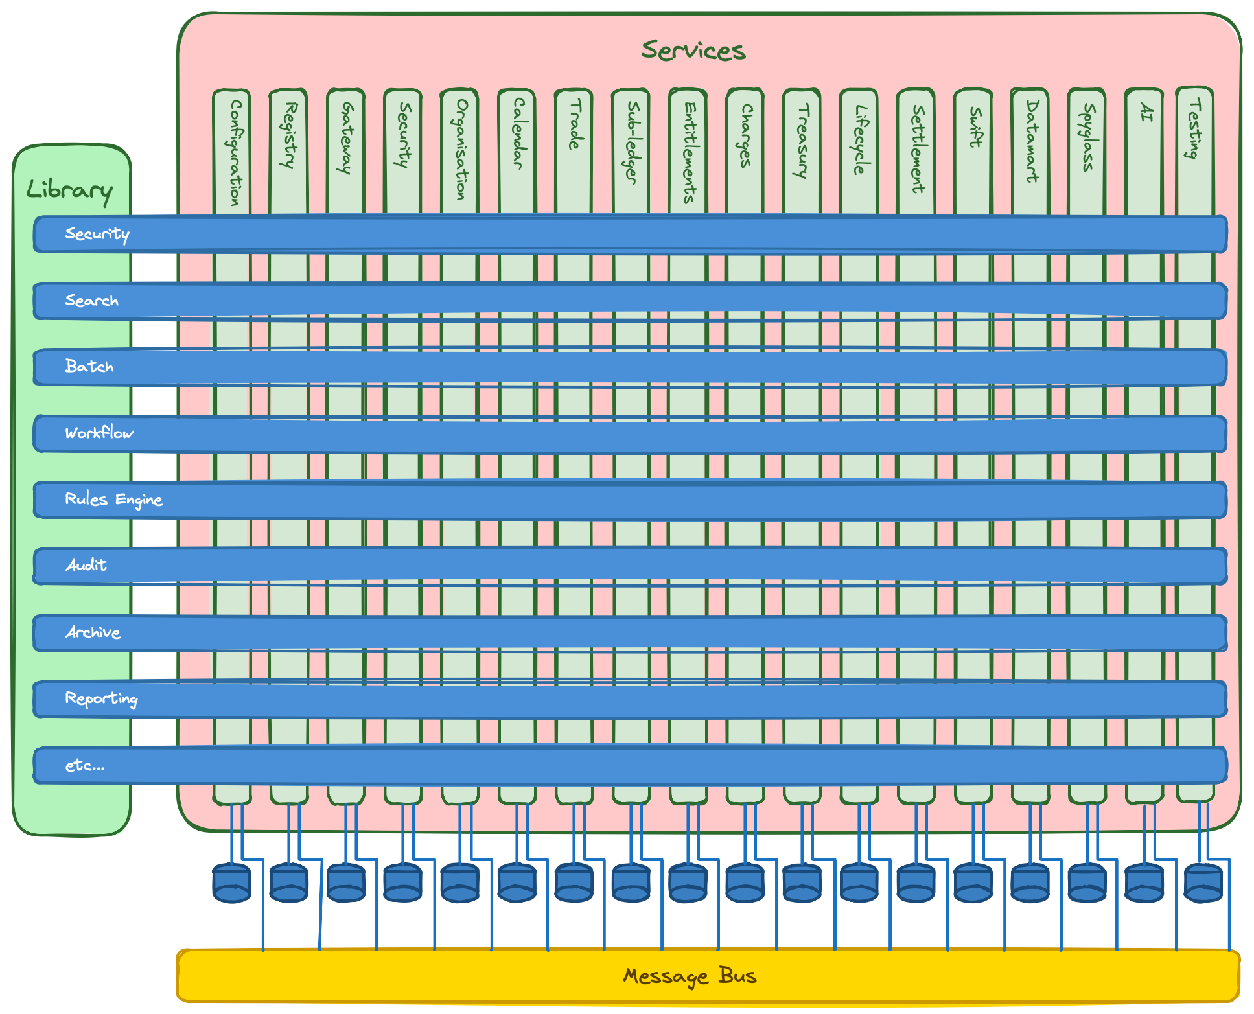
In plain terms, it has the shape of a serious banking or capital-markets backend platform, not a small application.

Stack the deck
The most important lesson is that AI works best when the odds are in its favour.
Large language models are probabilistic. They generate likely answers based on training data, context, and instruction. That means the best results come when the model is operating in a domain with a large, high-quality body of existing knowledge and when the task reduces ambiguity.
This is why AI can work well for code generation. Programming languages, common frameworks, public documentation, design patterns, and open-source examples create a large corpus of structured knowledge. Finance has something similar on the business side: published standards, regulatory material, vendor documentation, market conventions, and decades of shared terminology.
The practical implication is simple: stay close to the centre of the bell curve when you want the model to be useful.
For this project, that meant choosing what some people would call the boring technology stack:
- Java
- Spring Boot
- Unix-like deployment assumptions
- SQL
- Docker
- REST, GraphQL, and gRPC where appropriate
- standard financial terminology
- well-known architecture patterns
- English-language names and specifications
This was not a conservative choice for its own sake. It was a way of reducing entropy.
If I choose a well-known hexagonal architecture style, with ports and adapters, I do not need to spend half the prompt explaining my personal architecture. If package names, module boundaries, test conventions, and database patterns are repeated consistently, the model has less to infer. If the domain language is standard, the model has fewer opportunities to invent terminology.
In other words, every boring decision increases the chance of a useful AI result.
The goal is to stack the deck.

Guardrails matter more in regulated industries
AI in financial services cannot be treated like a clever autocomplete attached to production data. A heavily regulated industry needs guardrails.
The useful mental model is that AI agents should be treated like users. They should have access to specific functions and specific data. They should be constrained by workflow, permissions, tenancy, account identifiers, approval rules, audit trails, and operational controls.
An AI assistant that helps identify a settlement break is useful. An AI assistant with uncontrolled access to mutate production data is not.
This is one reason workflow matters. Exceptions, approvals, investigations, escalations, and manual interventions are often treated as separate pieces of functionality. In practice, many of them are specialised forms of workflow. If they can be modelled consistently, the system becomes simpler for people, easier to test, and easier for AI to work with safely.
The same applies to API design. GraphQL is useful not just because it is fashionable, but because the schema gives structure. Structure is good for humans. It is also good for AI. A model performs better when the valid shape of a request and response is explicit.

Monolith or microservices?
The honest answer is: both, depending on where the boundary actually belongs.
Microservices can provide clean ownership boundaries around data domains. They can help with scaling, resilience, and independent deployment. They also introduce structural complexity. In a financial system, most modules eventually need to know something about accounts, instruments, positions, parties, or reference data.
The rule I followed was that every service should own its source of truth, but other services may cache or project data they need for their own work.
For low-volume access, a service can call another service. For high-volume reporting or operational workflows, that is often not enough. Reporting on trades with account names, codes, lifecycle state, settlement status, and related cash movements may require local projections or database-level views.
SQL still matters. You cannot beat a database engine for generating large result sets when the data shape is understood. The key is to avoid confusing a projection with ownership. A cached view is not the source of truth.
For development speed, each service had its own database schema. Cross-schema SQL views were used as an early step where needed, with the option to replace them later with materialised views or event-driven projections. That allowed the system to move quickly without pretending that the first implementation was the final architecture.

The workbench UI
The operational UI was deliberately unglamorous.
AI is very good at generating modern-looking interfaces. UI frameworks and demos are everywhere. But for this product I wanted a corporate operations workbench, not a marketing site. Functionality mattered more than shine. The aim was user productivity: clear screens, predictable workflows, fast iteration, and minimal moving parts.
The UI approach was server-generated hypermedia using Spring templates, with Unpoly or htmx-style interaction and plain JavaScript where needed. No WebSockets initially. Request/response and REST were enough.
That does not mean every UI should be built this way. Mobile apps, client-facing portals, and specialised external interfaces may deserve their own technology choices. The platform exposes REST, GraphQL, and gRPC endpoints through a gateway, so different user experiences can be built for different purposes.
I am not a great believer in one UI for everyone. It usually becomes a compromise for everyone.

Codebase discipline
The codebase improved because the process was iterative and because reviews were strict. Entire rewrites happened. Usually that was not because the code was bad, but because the functional understanding had improved.
AI-generated code has its wobbles, even when API documentation is available. The review loop is therefore essential. Some of the most useful questions to ask the AI were not “write this code”, but:
- Does common code, pattern, or functionality already exist elsewhere?
- Should this be generalised?
- Are the business names and values being applied consistently?
- Are there conflicts with existing domain terminology?
- Where does this module deviate from the style of the other modules?
- What business or technical functionality appears to be missing?
- Is the BDD coverage complete for the use cases, workflow, and business process?
This review process mattered across the whole estate. The shared common sub-project eventually accounted for a large proportion of the codebase. That was both a strength and a risk.
The strength was consistency. Once strong patterns existed, AI found it easier to build new modules in the same shape. The risk was over-generalisation. I tried to avoid pushing business domain objects such as accounts and trades into the common layer. Each domain service should choose the structure that fits its work. Shared identifiers, however, were centralised. External IDs were typed and canonical in structure.
Using a strongly typed language helped. It gave both the human reviewer and the AI fewer places to hide ambiguity.

Did AI make enterprise software faster?
Yes, but not by magic.
The application reached deployment stage in Docker containers in roughly the equivalent of nine to twelve person-months of effort, compressed into a much shorter calendar period. Without AI, I would expect a comparable effort to require a team of perhaps seven to ten people over a couple of years.
That does not mean AI simply replaces the team. It means AI changes the economics of what a deeply experienced generalist can do.
The speed came from a combination of factors:
- choosing proven technologies
- creating repeatable patterns
- using BDD as executable specification
- reviewing aggressively
- refactoring when patterns repeated
- keeping domain language consistent
- asking AI for options before committing to infrastructure decisions
- slowing down when the problem was not yet well understood
The last point is important. AI can make it tempting to keep generating. That is dangerous. When the work involved infrastructure, architecture, or unclear domain concepts, the better move was to ask for options, compare trade-offs, and then decide.
When the knowns were known and the plan was clear, AI was extremely fast. When the problem was fuzzy, AI needed human judgement.
Fred Brooks wrote in “No Silver Bullet” that there is no single development breakthrough that removes the essential complexity of software. I still think that is true. AI does not remove the essential complexity of enterprise financial systems. But it can reduce a great deal of accidental complexity, especially around repetitive implementation, test scaffolding, documentation, refactoring, and pattern completion.
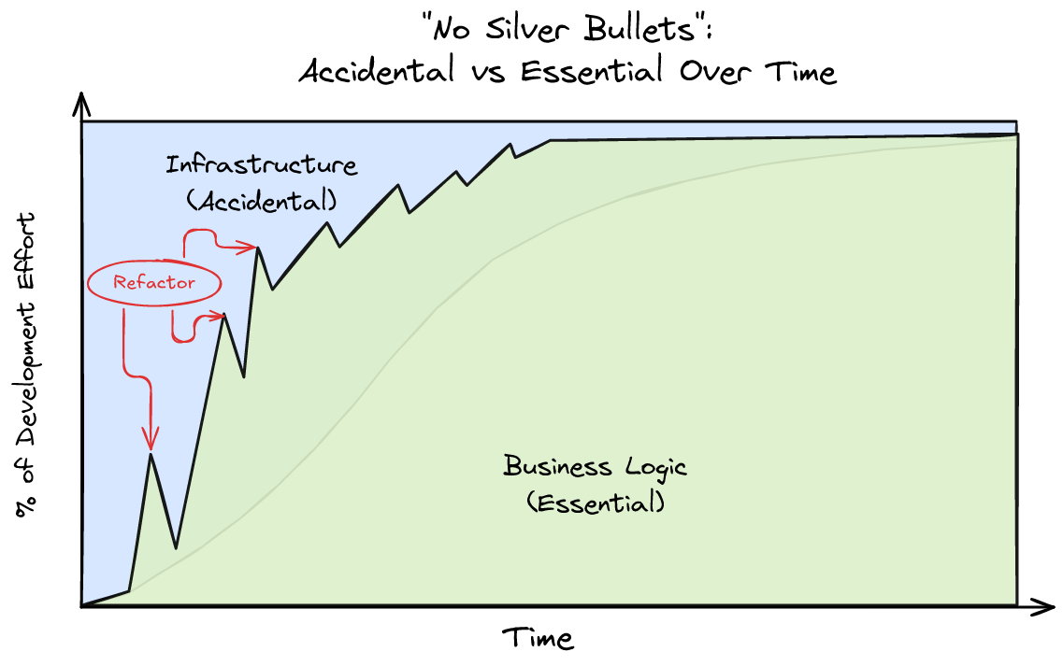

Letting go without generating slop
The way to get value from AI is not to let it do everything from the start.
At the beginning of the project, I micromanaged the work. I wanted the framework, naming conventions, architecture, test style, and boundaries to be clear. That was the blueprint. Once the patterns emerged, I could loosen control and review results at a higher level.
The “rule of three” was useful. When functionality appeared three times, I looked for the underlying pattern and refactored. Sometimes the commonality was obvious from the start and belonged in a shared library. Sometimes it emerged only through development.
Transactions and events were a good example. They eventually unified trades, cash, entitlements, and lifecycle activity. The more the system developed, the more it became clear that a trade is not just a static record. It is a series of temporal events, some of which may or may not happen, generating zero or more transactions depending on the terms of the trade.
That insight supports both simple trades and highly structured trades. But an LLM is unlikely to give you that model on the first pass. It can help you explore it. It can challenge it. It can generate alternatives. It still needs a human who understands the domain deeply enough to connect the dots.
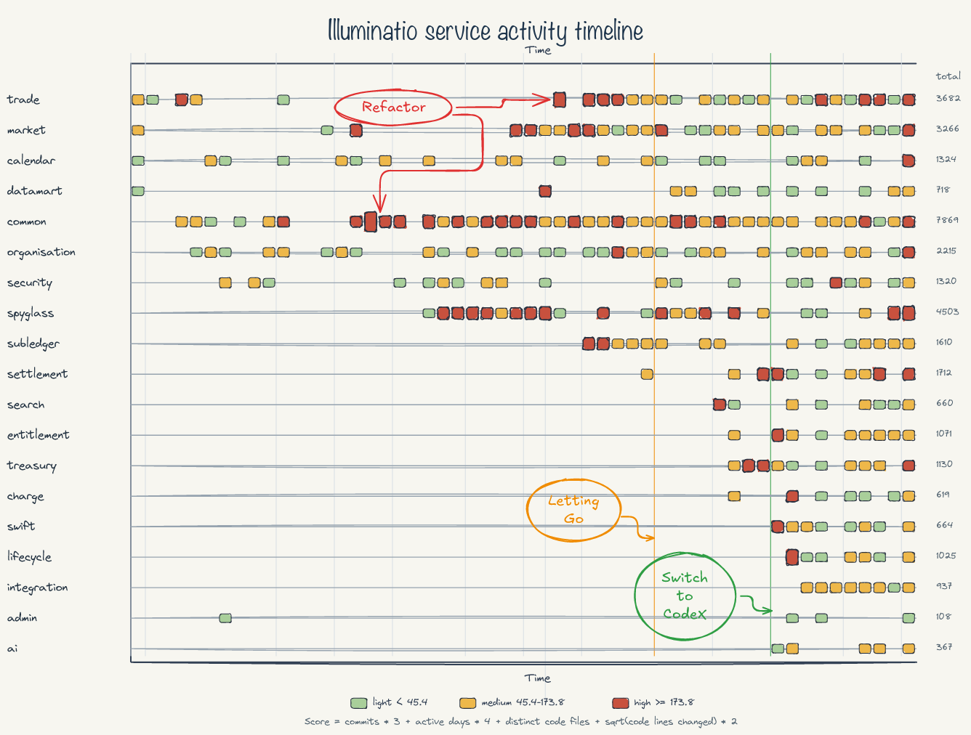
The same is true technically. Developers often create separate processes for exceptions, approvals, manual tasks, and investigations. AI will follow that habit because it has seen that habit. A human can notice that many of these are variations of workflow. Then several patterns become one pattern.
Less code. Fewer exceptions. More consistency. Better AI results.

BDD was the surprise
Behaviour-driven development became one of the strongest accelerators in the project.
LLMs perform best when the problem domain constrains the space of valid outputs. BDD does exactly that. Given/When/Then scenarios describe expected behaviour in clean language. They become executable specifications and living documentation.
For this project, most testing used BDD. Modules ran in test mode with controlled time and test endpoints. Feature scripts exercised the behaviour. Module-level steps could later be reused in integration-level tests.
This changed the development experience. Testing became part of the design process rather than an afterthought. AI could help write scenarios from domain knowledge, generate step definitions, implement missing behaviour, and then iterate against failures.
The key is test data discipline. You need a well-defined set of test data that can be extended. Test cases should be isolated enough to run in any order, while still representing realistic overlaps in the domain. That takes planning, but it pays back many times over.
The result was confidence without the brittleness that often comes from excessive low-level unit tests. If the BDD suite passes across the relevant workflows, you have meaningful evidence that the system behaves as expected.

What this means for financial institutions and vendors
The implications for the financial industry are significant.
Buy versus build has always been a difficult decision. Vendor platforms offer speed, expertise, and packaged capability. Internal builds offer control, specificity, and ownership. Historically, the internal build option was constrained by time, team size, and risk.
AI changes that balance.
It becomes more plausible for smaller, sharper teams to build serious systems if they have:
- deep domain knowledge
- disciplined architecture
- strong test automation
- familiar technology
- clear terminology
- operational guardrails
- enough engineering judgement to know when not to trust the model
This creates pressure for SaaS and enterprise vendors. They still have advantages: product maturity, sales channels, regulatory credibility, support, integrations, and procurement familiarity. But their customers will increasingly ask why a system costs so much, takes so long to change, and still does not fit.
At the same time, institutions may decide to consume or acquire smaller AI-enabled product teams rather than buy large vendor platforms. The barrier to entry will not disappear, especially in regulated finance, but the economics are shifting.
The future may also revive an older job shape: the analyst/developer. In an AI-assisted world, a person who can understand the business, shape the architecture, write and review code, define tests, and operate the system has extraordinary leverage.
The old phrase is apt: “A jack of all trades is a master of none, but oftentimes better than a master of one.”

Conclusion: stay on the path
AI has made it faster to build enterprise financial software, but it has not made the hard parts disappear.
The lesson from this project is not “let AI build the system.” The lesson is: create the conditions in which AI can be useful.
Stack the deck. Stay within the bell curve. Use boring, well-documented technologies. Keep the domain language clean. Build around known patterns. Constrain the model with executable specifications. Review aggressively. Refactor when repetition appears. Treat AI agents as users that need permissions, workflows, and audit trails.
Most of all, use AI to amplify engineering discipline rather than bypass it.
The surprising result is that the beginning may feel slower. There is more hand-holding, more pattern-setting, more review, and more deliberate structure. But once the path is clear, the speed changes dramatically. Modules that would previously have taken weeks can become days.
For enterprise finance, that is not a small shift. It may change who can build, what can be built, how quickly institutions can respond, and how much tolerance remains for systems that survive only because replacing them used to be too hard.

